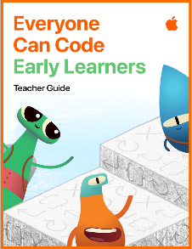






KEY VOCABULARY
permission/responsibility *markup/crop/zoom/focus/rotate cartoon/comic strip landscape repeat photo album
copyright clipart composition voice-over tempo pitch loops trailer green screen

Presenting
- I can make digital books and slideshows in Pages and Keynote
- I can make charts from tables I have created to present data using Numbers
Coding
Focus: Loops (p22-28)
- I can begin to understand a loop as a repeated set of commands
- I can explore why loops always need a specific end point
- I can create a loop and determine how many times it needs to be called

Film (Video & Film)
- I can create a film trailer using iMovie
- I can add music and sound effects to films I have created
- I can use the green screen and software independently
Music (Sounds)
- I can create and edit a sound composition e.g. voice over, tempo, pitch
- I can create loops of the compositions I have created
Drawing (Images)
- I can create a cartoon or comic strip
- I can draw landscapes using appropriate tools
- I can discuss copyright when I search for images and clipart when using a search engine
Photography
- I can rotate a photograph
- I can discuss the importance of permissions and responsibility when taking/using photographs
- I can create a photo album to organise a collection of photos
*Continue to practice skills from Y1/2: Markup, cropping, zoom, focus, rotation

