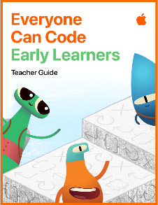






KEY VOCABULARY
Colour filter edit crop mark-up trace opacity still-life ownership composition trim microphone green screen voice over digital books equation commands functions

Presenting
- I can make digital books with my own photos, music and videos using Pages
- I can create my own tables in Numbers to present data
Coding
Focus: Functions (p15-21)
- I can explore the idea of packaging a series of commands and giving it a name
- I can solve a simple equation by using directional commands
- I can write a function composed of several different types of commands
Film (Video & Film)
- I can create a voice over for images chosen
- I can begin to use the green screen to create a short film/video with support
Music (Sounds)
- I can create a simple sound composition using two or more instruments
- I can trim sounds for effect
- I can explore the microphone and its effects
Drawing (Images)
- I can trace around objects or people by reducing opacity
- I can draw still-life pictures using appropriate drawing tools
- I can discuss the meaning of ownership in terms of digital work
Photography
- I can explore colour and filters and choose appropriately for the photograph I have taken
- I can edit a photograph by cropping it
- I can use the mark up tools to edit my photos

