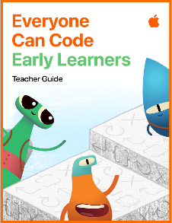






KEY VOCABULARY
zoom in/out landscape portrait fill tool palette fonts/text record volume
pause command sequence moveForward() turnLeft() insert type

Presenting
- I can insert photos into Pages or Keynote for a specific purpose
- I can type short titles/captions
- I can type numbers into a table in Numbers
Coding
Focus: Commands (p8-14)
- I can understand what a command is and issue commands such as moveForward()
- I can explore sequences and create my own to get to a desired location
- I can create a sequence of commands to achieve a desired outcome
Film (Video & Film)
- I can use the Camera app to record a short video for a specific purpose
- I can zoom in and out when recording a video
Music (Sounds)
- I can create a sequence of sounds
- I can record a sequence of sounds
- I can use the volume and pause functions
Drawing (Images)
- I can use the fill tool to quickly colour an object, shape or area
- I can select colours from the colour palette
- I can explore fonts and add text to my drawings
Photography
- I can take a portrait photograph
- I can take a landscape photograph
- I can explain the difference between a portrait and landscape photograph
- I can zoom in and out on a subject

