The topic for this half term is ‘Everything Changes’. Below is a grid. Each different piece of homework is worth a certain amount of points. You need to complete AT LEAST 20 points worth of homework by the deadline (of course it can be brought in earlier). Spellings may be given on top of this and you are still expected to read 4x weekly. Homework to be completed in homework books.
Can you find pictures of baby animals and label these with their correct names. What will these be when they grow up?  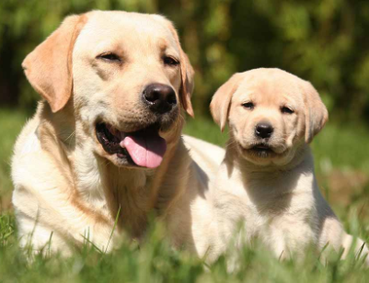  5 points | Watch how the weather changes. Can you tell me the weather on three different days? Record this in some way.  5 points | Create a number line to 20- be creative! You could write the numbers in crayon, pencil paint, chalk or use something else, like beads, apples, leaves, sticks, or anything you like!  5 points
How tall are you? How tall are your family members? Measure yourself and 2 other people and write down their heights. I wonder who the tallest is? I wonder who the shortest is? Can you tell me?  10 points | In PE this half term we have been focusing on Dance, can you record your favourite dance and send it into us.  10 points | Can you draw a picture of a flower and label all the different parts.  10 points
Read the hungry caterpillar. Write a short review telling us your favourite part.  Visit  https://www.youtube.com/watch?v=75NQK-Sm1YY  to listen to the story.  15 points | . Can you find seeds in your foods? Write a list, or draw the foods that you find.  15 Points | How do we look after animals? If you have a pet can you create book of photos or drawings plus either words or sentences to tell someone how to look after them? If you don’t have a pet, choose an animal and tell us the things that animals needs to stay happy and healthy.  15 points

