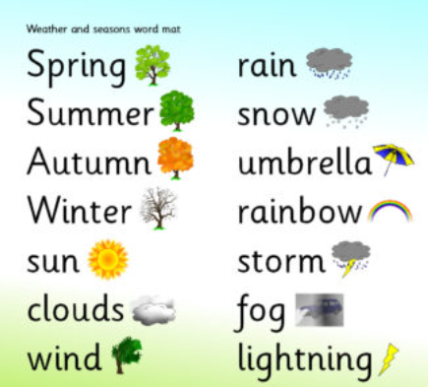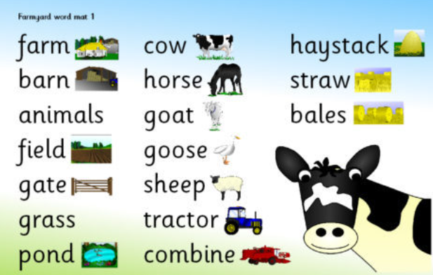

Habitats Animal homes
Ocean Cave
Jungle Den
Rockpools Kennel
Woodland/ Forest Coop
Polar regions Nest
Deserts Pond

