OUR
SUPERHEROES
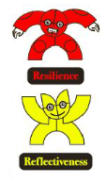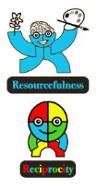

Create your own superhero, what are they called? What is their super power?  8 Points | Learn some different nursery rhymes  2 points | Show what things make you happy, this could be pictures, drawings or writing.  8 points
Show what things make you sad, this could be pictures, drawings or writing.  8 points | Show us what you want to be when you grow up, this could be pictures, drawings or writing.  8 points | Using different shapes can you make a shape picture  8 points
Look for different numbers in the environment, which do you find?  5 points | Be Mr resourceful, collect some things at home and use them to make something  3 points | Be Mr Reciprocity, tell us about something that you have had to try hard with  5 points
Foundation Stage Homework Grid Due in: 21st October

Above is the grid of the different pieces of homework your child can complete during this half term. Each different piece of homework is worth a certain amount of points. You need to complete AT LEAST 20 points worth of homework by the deadline (of course it can brought in earlier if you complete things during the term). The 20 points may be achieved by doing one activity or choosing two or three, however you may choose to do them all. Children may be asked to learn spellings on top of this or be asked to do an additional activity linked to work in class if they need reinforcement. You are still expected to read 3x weekly.

