Key Vocabulary
town | A town is a place where people live and work. There may be shops, schools, places of worship and other facilities. It is smaller than a city. | 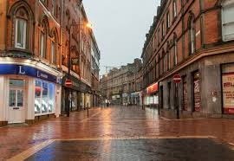
countryside | This is land that is not a town. They can be small, there are lots of grass, farmland and woodland. | 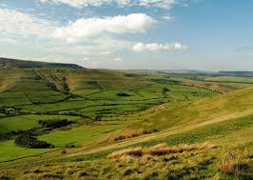
country | An area of land with it’s own government, rules and borders. | 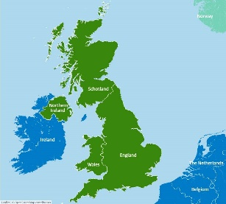
UK | The United Kingdom is made up of 4 countries: England, Scotland, Wales and Northern Ireland.
island | An area of land surrounded by water. | 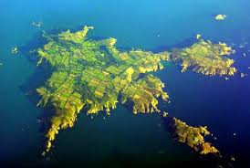
landmark | A feature or landscape that is easily recognised. It could be made by humans or something that occurred naturally. | 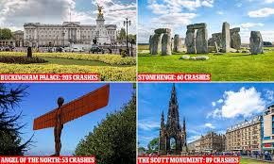
population | How many people live in one particular place | 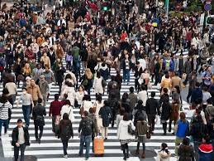
capital city | A town or city where the government sits. | 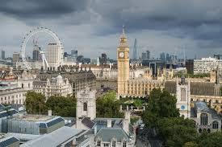
Local Area and the UK
Knowledge Organiser Year 1

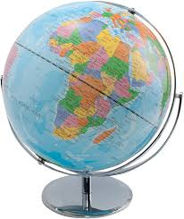
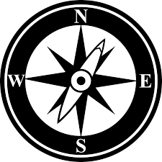
A compass is used to help find the way or to show the position of something. It has 4 points – North, East, South, and West. A globe shows the whole world.

A map of Derby A birds eye view of Derby
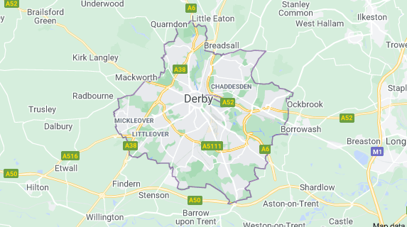
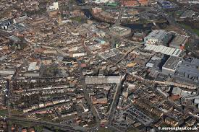

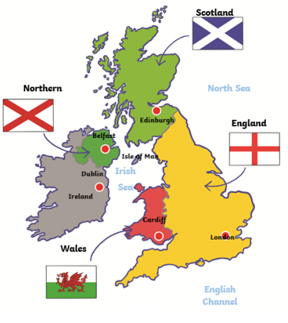

This is a map of the UK. It shows the 4 countries that make up the UK. It shows flags of each country. The capital cities of each country are labelled.

What should I know?
I live in Allenton. Allenton is a town in Derby. The country I live in is called England, this is part of the UK.
What should I know by the end of this topic?
- I will be able to name and locate the 4 countries on the map of the UK.
- I will be able to name the 4 capital cities and locate these.
- I will be able to identify landmarks in each of the countries.
- I will be able to name the surrounding seas.
- I will be able to use a map/globe and correctly use a compass to navigate.

