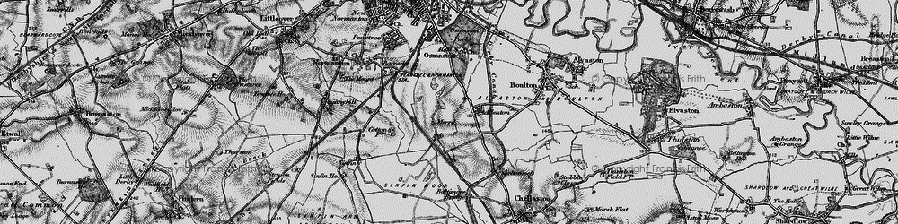
English
This term in English we will be reading the story of ‘Little Red Riding Hood’. Once we have read the story we will learn how to retell the story. We will focus on using capital letters, finger spaces and full stops.
Phonics
In phonics we will be recapping our phase 2 sounds and we will begin to learn our phase 3 sounds.

PE
This term in PE we will be focusing on ‘Fundamentals’. This includes;
Basic movements
Spatial awareness
Balancing

RE
This term in RE we will be focusing on the key question ‘Who is a Christian/Jew and what do they believe?’

PE
Shared Reading
This half term in shared reading we will introduce the children to the different VIPER skills. We will cover a new skill each week and support the children with using these skills when reading.
PE
Maths
This term in Maths we will be following the ‘Maths no problem’ syllabus. We will focus on;
- Numbers to 10
- Number bonds
- Addition within 10
- Subtraction within 10
Memorable events and dates:
- Roald Dahl Day
- Jeans for Genes Day
- Black History Week
- Macmillan Coffee Morning
Computing
This term in computing we will focus on using I Pads safely and correctly. We will also be focusing on our photography skills.
Topic
This term our topic is ‘Street Detectives’. This topic will have a strong history focus. During this topic we will
- Learn about the history of Allenton Community Primary School
- Learn about the history of Allenton – looking at old shops and how they are similar and different.
- Look at homes/houses and how they have changed since the past
- Plan, design, build and evaluate their own shop or house using different materials.
- Learn about Isaac Allen and the Allenton hippo.
Street Detectives
Autumn 1
Year 1 – 2021/22

