Vocabulary | Definition | Image
Map | A map is a picture or drawing that shows the location of somewhere. | 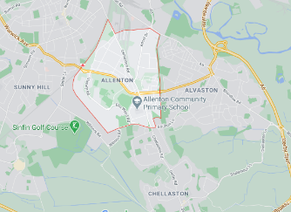
Directions | Words that describe how to get somewhere. North, East, South, West, up, down, left and right. | 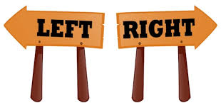
Route | A route is the way you go to reach a place. A set of directions to get from one place to another. | 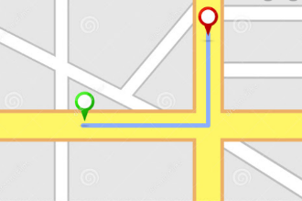
City | A large town, a place where people live. Derby is a city. | 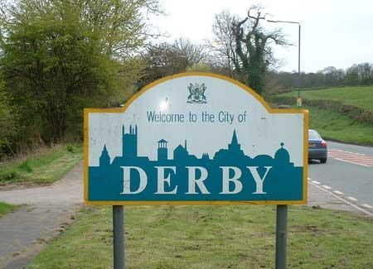
Year 1 – Street Detectives – Knowledge Organiser

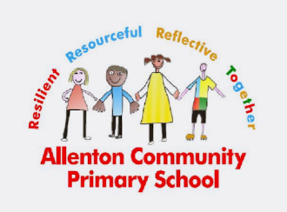

A community is made up of the people living there. A community can change over time. We belong to Allenton Community Primary school, and you belong to the community where you live.

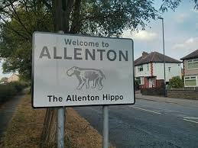

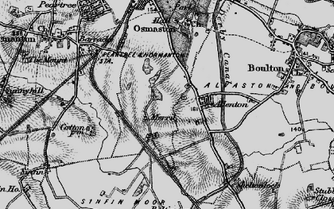
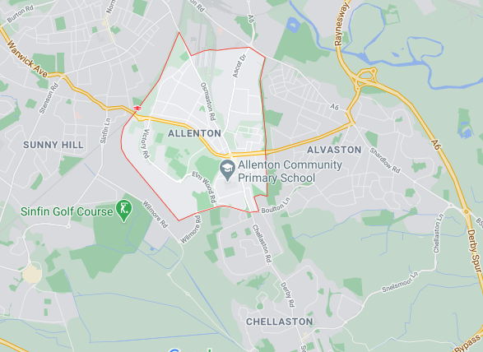

A modern map showing Allenton An old map showing Allenton
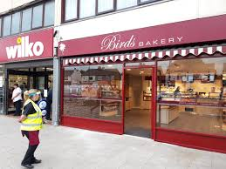
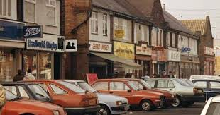

These shops were in the past. These shops are in the present.

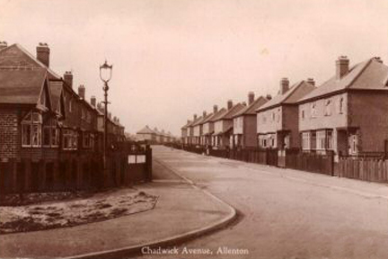
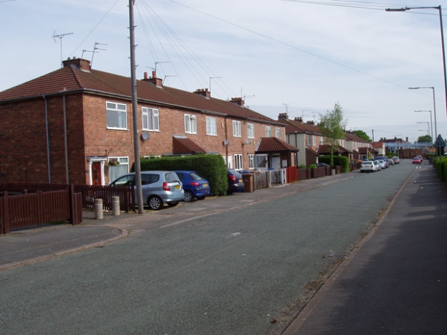

These homes were in the past. These homes are in the present.

