Wonderful Weather – Year 1 Knowledge Organiser
Key Vocabulary
climate | Climate is the average measurements of temperature, wind, humidity, snow, and rain in a place over the course of years.
equator | The Equator is an imaginary line that is drawn around the middle of the Earth to divide it into the Northern and Southern Hemispheres.
weather | There are four seasons: Spring, Summer, Autumn and Winter. The length of a day varies depending on the season.
temperature | A measure of how hot or cold  something is.
forecast | A prediction of what the weather will be like in the future.
seasons | The year is divided into four seasons: spring, summer, autumn and winter
extreme | Beyond what is normal
thermometre | An instrument used to measure temperature..
affects | Makes a differnece to.
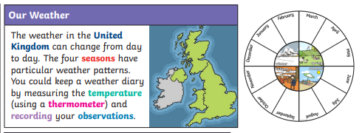
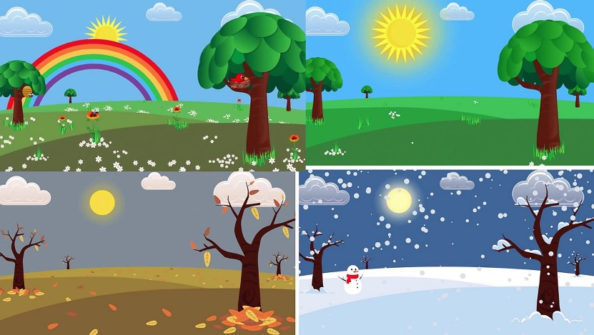

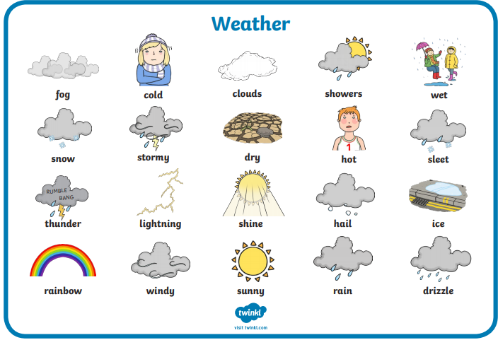
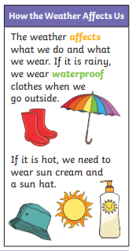
Spring Summer Autumn Winter
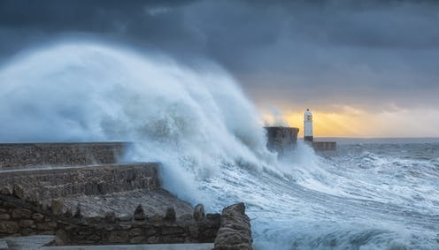
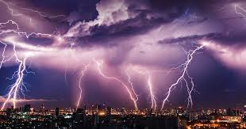
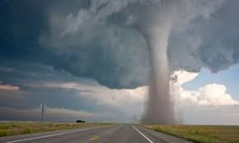
There are many types of extreme weather. Extreme weather can be very dangerous and affects us and our surroundings.

Climates
Countries around the world have different climates. Countries near the equator have hotter climates whereas countries near the Artic and Antarctic have much colder climates. Climates can affect many things, including where extreme weather occurs.
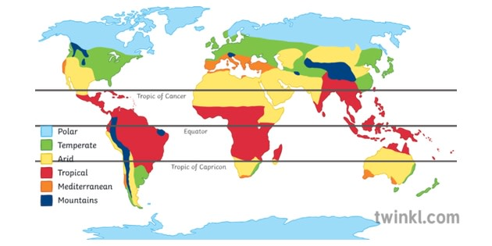
These are used to measure and track the weather:

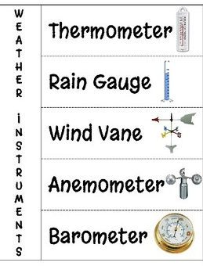
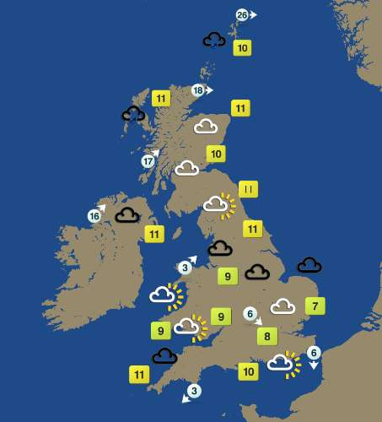

Weather map of the UK showing a forecast.

