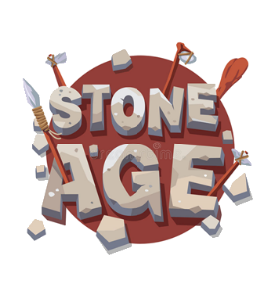
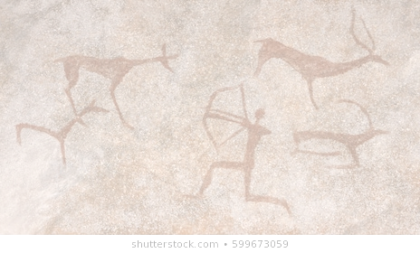
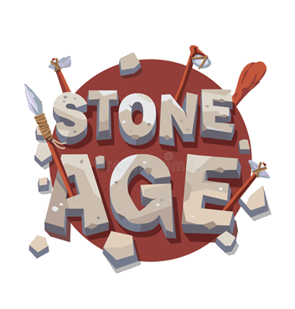
RE
We are learning about holy places of worship and holy books for both Jews and Christians. We will be thinking about the Christian festival of Easter and the Jewish festival of Pesah.

PE
We are looking at skills we can use when playing games including running with a [ball, passing a ball. We will then think about team games skills including attacking and defending, before putting these skills into a team game.

Maths
We are following ‘Maths No Problem’ at school. This half term we will be learning;
Division
Fractions
Numbers to 100
Time
Money
Volume and capacity

Music
Find out about prehistoric musical instruments and compare them to instruments today
Research Stone Age Musical stones and have a go at making your own set.
Compose music for a journey through a cave

D&T
We are going to look at design to help the children model and communicate their ideas.
They will design and make Stone age tools out of paper Mache and a structure of Stonehenge this half term.

Topic
This term our topic has a strong history focus. Our focus of our topic will be ‘Stone Age’. We will be learning about;
What is the Stone Age?
How did people live in the Stone Age?
What did people in the Stone Age eat?
How did people communicate in the Stone Age?
In D & T we will be looking at; Cave paintings, stone jewellery.
English
In English this term we will be looking at the story ‘Stone Age Boy’. We will spend time looking at different writing features such as capital letters, full stops, question marks, exclamation marks and adjectives. We look at the beginning, middle and end of the story and rewrite main events in these parts.

Key questions for this term
Who is Charles Darwin?
How did homes change through the Stone Age?
How did people communicate in the Stone
Age?

Phonics
In phonics we will be following the ELS scheme. We will continue to revisit Phase 3 and 5 as well as learn all the alternative phonemes.

Year 1 Spring 2 2022
Topic Web

