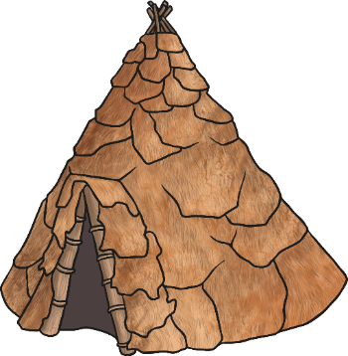
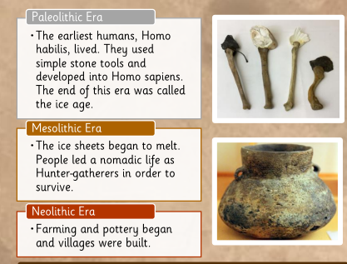
Stone Age– Summer 1 – Year 1
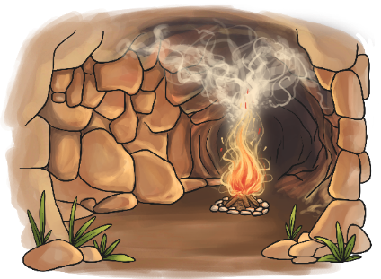

Stone Age homes
Homes changed through the Stone Age. People used to live in caves, then they built tents from animal skin and then towards the end they built huts from stone and straw.

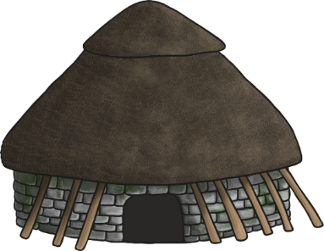
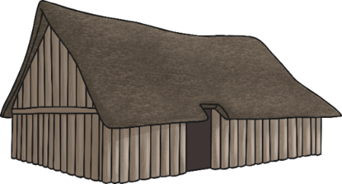

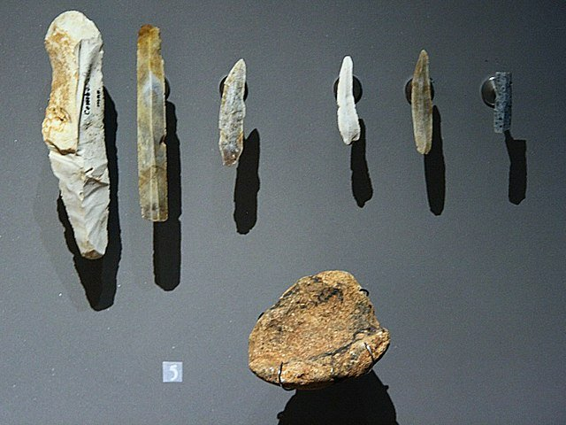
Stone Age tools
In the Stone Age tools were made from natural materials such as rocks and stones.
These tools were used for hunting, making fires, and building.

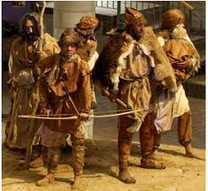
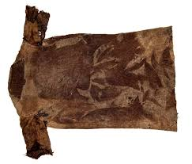
Stone Age clothes
Stone Age people wore animal skins, such as this tunic made from red deer skin. They had to make clothes out of the things they could find.

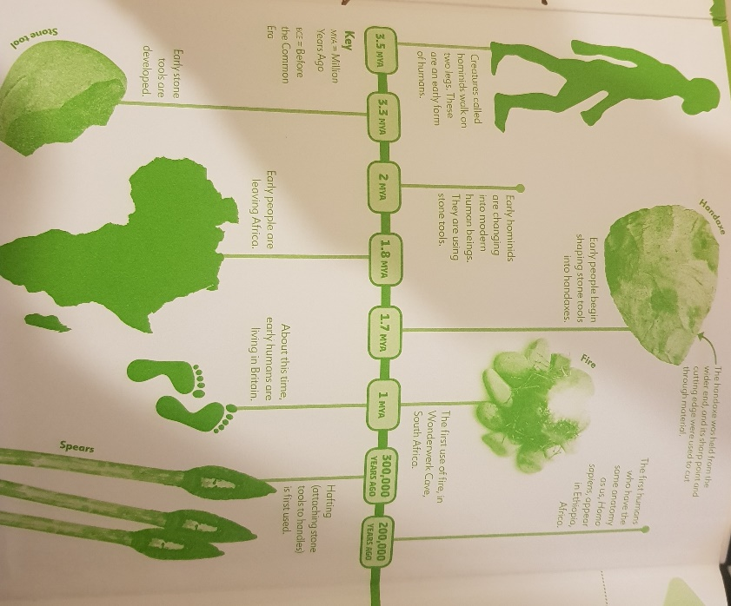
Time line of the beginning and the end of the Stone Age
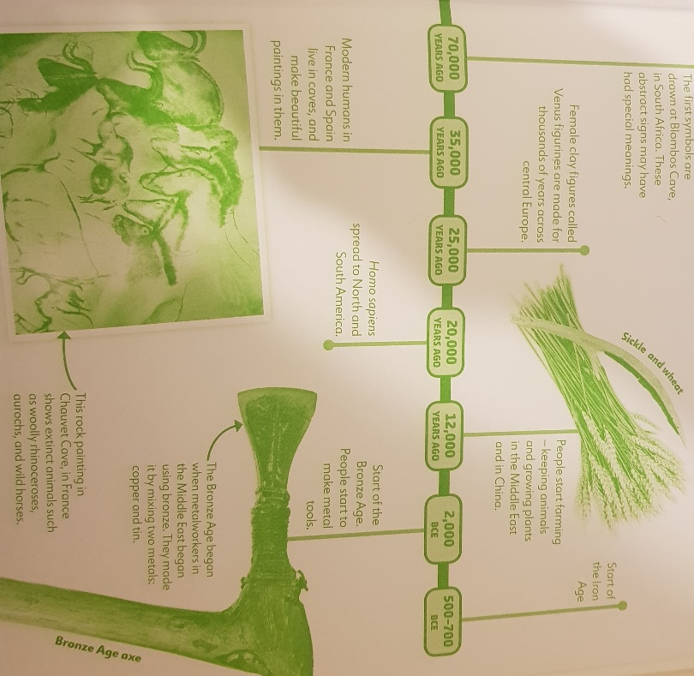
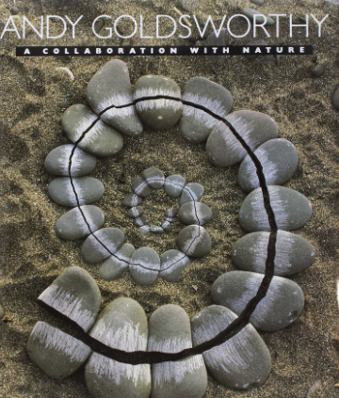
Andy Goldsworthy is a British artist we will look at this half term The materials used in Andy Goldsworthy's art often include brightly coloured flowers, icicles, leaves, mud, pinecones, snow, stone, twigs, and thorns.

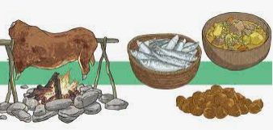
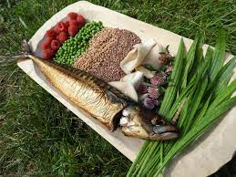
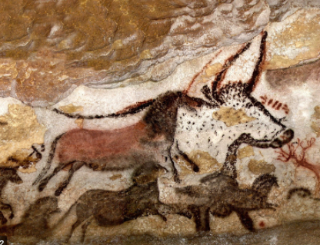
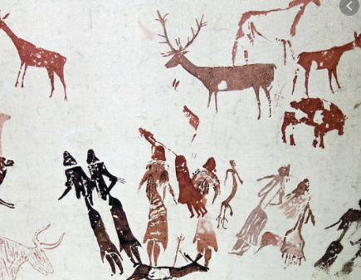
Stone Age food varied over time and from region to region, but included the foods typical of hunter gatherers: meats, fish, eggs, grasses, tubers, fruits, vegetables, seeds and nuts
Palaeolithic Artwork and Mesolithic artwork (Stone Age artwork)

