The main topic for this half term is ‘The Stone Age’. Below is a grid. Each different piece of homework is either 5, 10 or 15 points. You need to complete AT LEAST 20 points worth of homework by the deadline (of course it can be brought in earlier). Phonics activities may be given on top of this and you are still expected to read 4x weekly. Homework can be completed in homework books or sent via Class Dojo or Showbie.
People in the Stone Age used to use marks when counting. Can you how many toys or books you have and use tally marks to record this?  5 points | Draw a picture of what your cave would look like if you lived in the Stone Age.  5 points | Would you like to live in the Stone Age? Write a list of good things and bad things about living in the stone age.  5 points | List all the jobs that people had to do during the Stone Age. Can you list at least 5 jobs?  5 points
Create a Venn diagram of modern tools, Stone Age tools and tools that were created in the Stone Age that we still use today.  10 points | Draw and list all the animals that existed during the Stone Age.  10 points | Make your own flashcards with the sound and a picture to practise phase 5 sounds:  ay, ou, ie, ea, oy, ue, aw, wh, ph, ew, oe, au, ey, a-e, i-e, e-e, u-e, o-e.  10 points | Design and make your own fossil.  10 points
Create types of paint by crushing berries, grass, leaves and other natural materials. Use the paint to make a picture.  15 points | Using a variety of materials, create a small model of a Stone Age dwelling or monument, such as Stonehenge.  15 points | Create a poster of your 10 favourite Stone Age facts.  15 points | Create an acrostic poem using the words ‘Stone Age’.  15 point
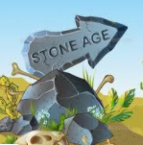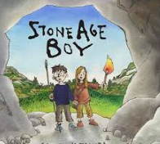
The Stone Age Spring 2 Homework Grid
Due in: Monday 4th April 2022

