Contrasting Locations – Year 1 Knowledge Organiser
Urban | Is a town city, built up area.
Rural | The countryside
City | A large important town, normally with a catherdral
Town | A place with many houses, shops, offices and buildings.
Hill | A piece of ground that is higher than the ground around it.
Valley | A long low area between hills, often with a river flowing through it.
village | A group of houses in a small country district.
Factory | A large building where machines are used to make goods.
Forest | Trees and undergrowth covering a large area.

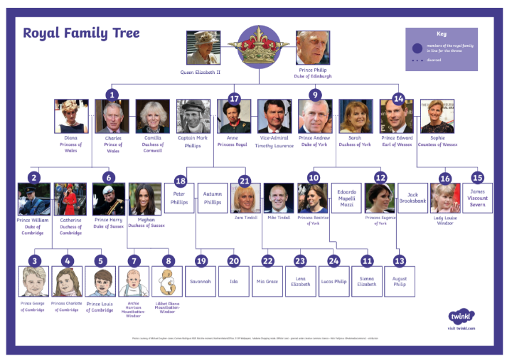

The Royal family Tree- the Queen is a significant person in History

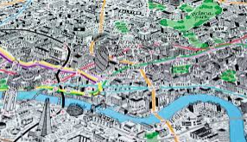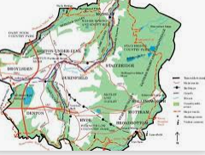
Comparing a city to the countryside on maps

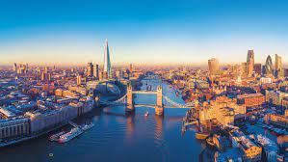
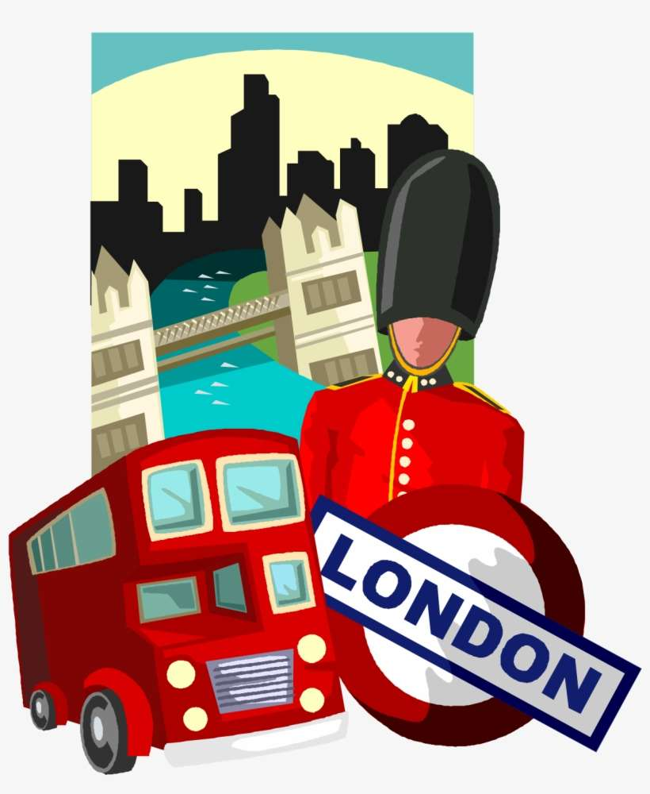
London is the capital city of the UK
It is the largest city in England and has a population of around 9 million people. London is a busy, built up city with lots of important places and landmarks.
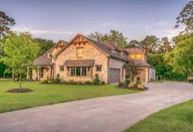
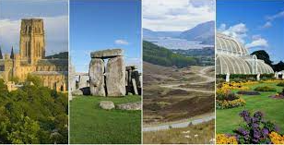
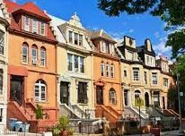
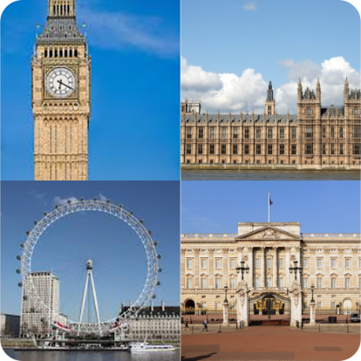

Country homes and town houses
Comparing rural and urban landmarks.

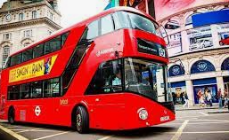
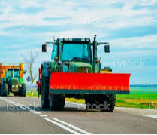
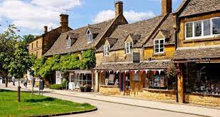
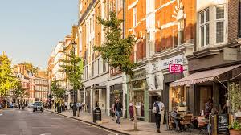
Transport for the countryside and the city
Shops in the city and in the countryside

