The main topic for this half term is ‘Continents and Oceans’ An exciting journey around the world!
Below is a grid. Each different piece of homework is worth a certain amount of points. You need to complete AT LEAST 20 points worth of homework by the deadline (of course it can be brought in earlier). In addition to this you are still expected to read 3x weekly. Homework can be completed in homework books or in a separate folder if you would prefer.

Complete weekly spelling activity and return it to school.    2 points each week | Make a globe of the world showing the seven continents and 5 oceans.  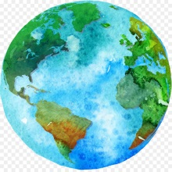  10 points | Create a poster to help you learn the 2, 5 and 10 times table.    4 points each poster | Write a fact file about one of the continents. Think about the climate, the landscape and any famous landmarks.  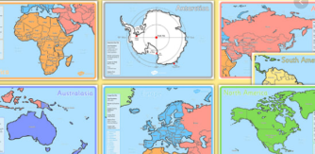  5 points | Complete weekly SPaG activities and return it to school.    2 points each week
  Choose a place you would like to visit. Draw and label what you would need to pack in your suitcase.  6 points | Complete weekly Maths activity and return it to school.    2 points each week | Try a food from a different country. Send a picture on dojo or Showbie.    3 points | Research famous art works from different countries. Try and make your own using different mediums. Eg: chalk, paint, pencil    2 points each week | Research and record how to say hello in different languages around the world.    5 points

