  - The main topic for this half term is ‘Plants.’ Below is a grid. Each different piece of homework is worth a certain amount of points. You need to complete AT LEAST 20 points worth of homework by the deadline (of course it can be brought in earlier). Homework can be completed in homework books or in a separate folder if you would rather. Children are still expected to read at home at least 3 times a week and will receive a reading treat in class if they achieve this.
Carefully weigh ingredients to make a cake. Send a photo (or a slice of cake )  15 points   | Design a seed packet for a new and exciting flower of your choice.  3 points  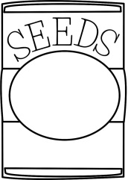 | Make a flower, plant or tree COLLAGE using magazine pictures and different materials.  15 points  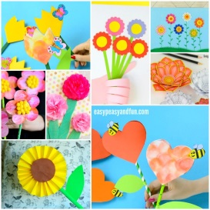 | Make a picture graph of your friends and families favourite colours.  8 points  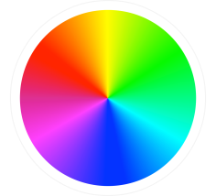 | Complete weekly spelling activity and return it to school.  2 points each week  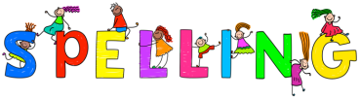
Look at plants and flowers. Take a close up picture of the plant and send it in  15 points  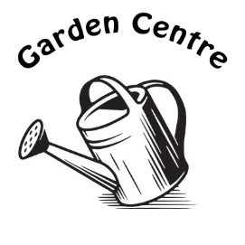 | Complete weekly handwriting activity and return it to school.  2 points each week   | Investigate and record all the different ways you can make 20p.  10 points  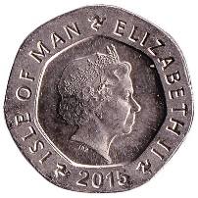 | Complete weekly Maths activity and return it to school.  2 points each week  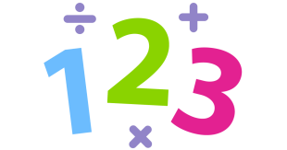 | Make a display poster for the rhyme,  Mary, Mary Quite Contrary, How does your garden grow?  6 points  

