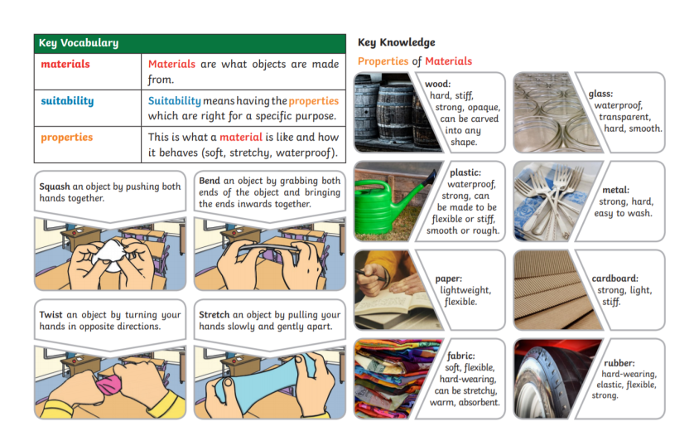
Year 2 Knowledge Organiser—Materials

